Removable Hood Installation
Chapter 1

Locating and Installing the Hood Sticks:
The goal was to have a hood that, without too much inconvenience, could be completely removed from the frame and stored somewhere other than in the boot when not in use. Because I hate driving with the hood up and carry it only as a last resort should I misjudge the weather (i.e., get caught in serious rain) I was willing to sacrifice a small amount of convenience for the benefit of full removability.

The first step which was the same as with a conventional installation was to locate the hood sticks. The frame had been installed by the PO but apparently the locations of the pivot points were selected pretty much at random. Even without the canvas the frame would not fold into the boot and it could barely be hooked over the windscreen posts.

Following the lead from Dave Braun’s site, I set the height of the horizontal member above the lowest point in the door sill at 19-3/4 inches. I hooked the front cross piece over the windscreen posts and clamped the pivot flats to the inside of the tub. I took a look and saw that the passenger side of the frame was noticeably higher than the driver side (I had no expectation that my car would be “square”). To accommodate this I shortened the passenger side height to 19-1/2 inches and relocated the passenger side pivot flat accordingly.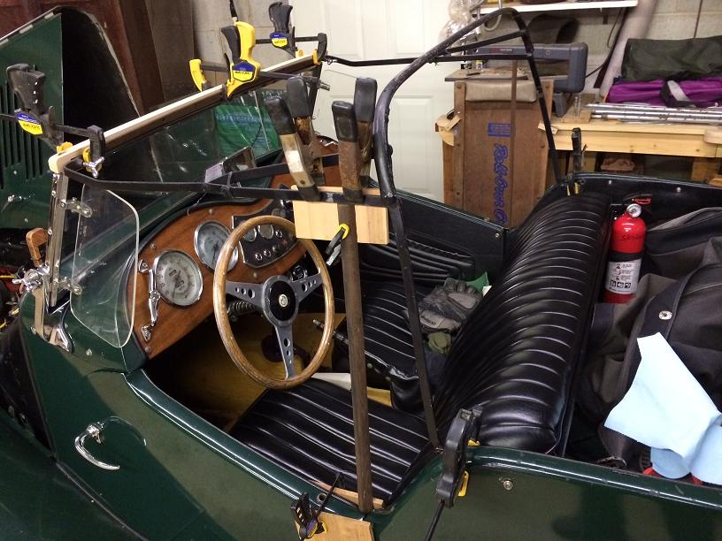

Once I was satisfied with the location of the sticks, I marked the location of the holes in the pivot flats and drilled some pilot holes into the tub wood. I followed these drillings with larger ones that allows me to insert 10-24 brass threaded inserts so that I can unscrew the and rescrew the thing without augering out the hole as one is wont to do with wood screws.

Installing the Top Rail and Side Stays:
I wanted to be able to remove the top rail and detach to side stays without having to cut or undo the excluder strip. I attached the top rail to the front of the hood frame with 10-24 SS machine screws into brass threaded inserts. Before attaching the top rail I carved out reliefs to the folded edge of the side stay straps and attached the straps to the metal rail with SS machine screws and acorn nuts. 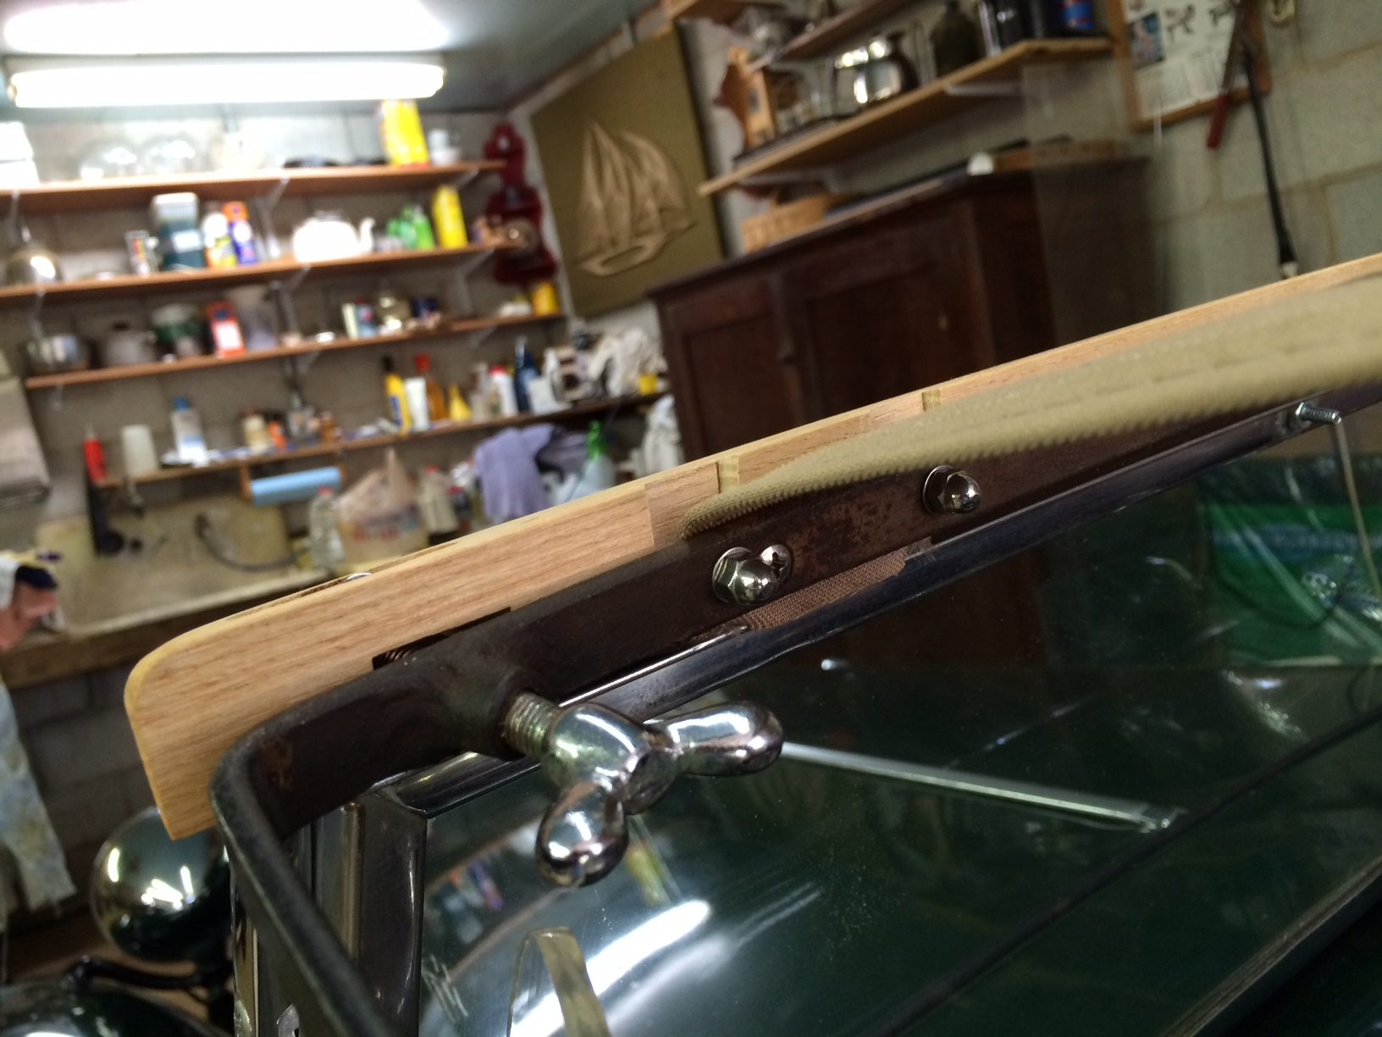

Not unlike Dave B, I was unable to figure out how to install the copper liners in the holes for the windscreen posts so they are still in a baggy on my parts wall.

Installing the Side Stays Rear:
Following the lead of Dave B and others, I did not want to attach the hood to the rear tacking strip with screws or anything permanent and I decided that I wanted the same for the rear attachment of the side stays so the complete removal of the hood sticks would be relatively easy. I figured if snaps work for the hood they’d also be OK for the side stays so that how I proceeded. The initial plan was to secure the stay with a single snap as shown.
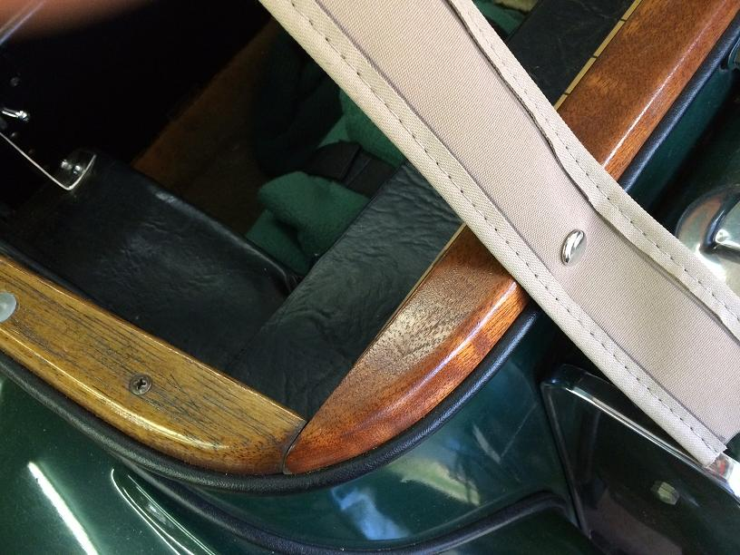

It turns out totally by coincidence (but I’d do it on purpose if doing it again) that the single snap for the side stay on the tacking strip aligns exactly with the outer rear snaps for my tonneau cover so the clean things up a bit I folded up the end of the side stay strap, put in another snap to hold the fold in place and located that snap over the tonneau male snap, to wit:
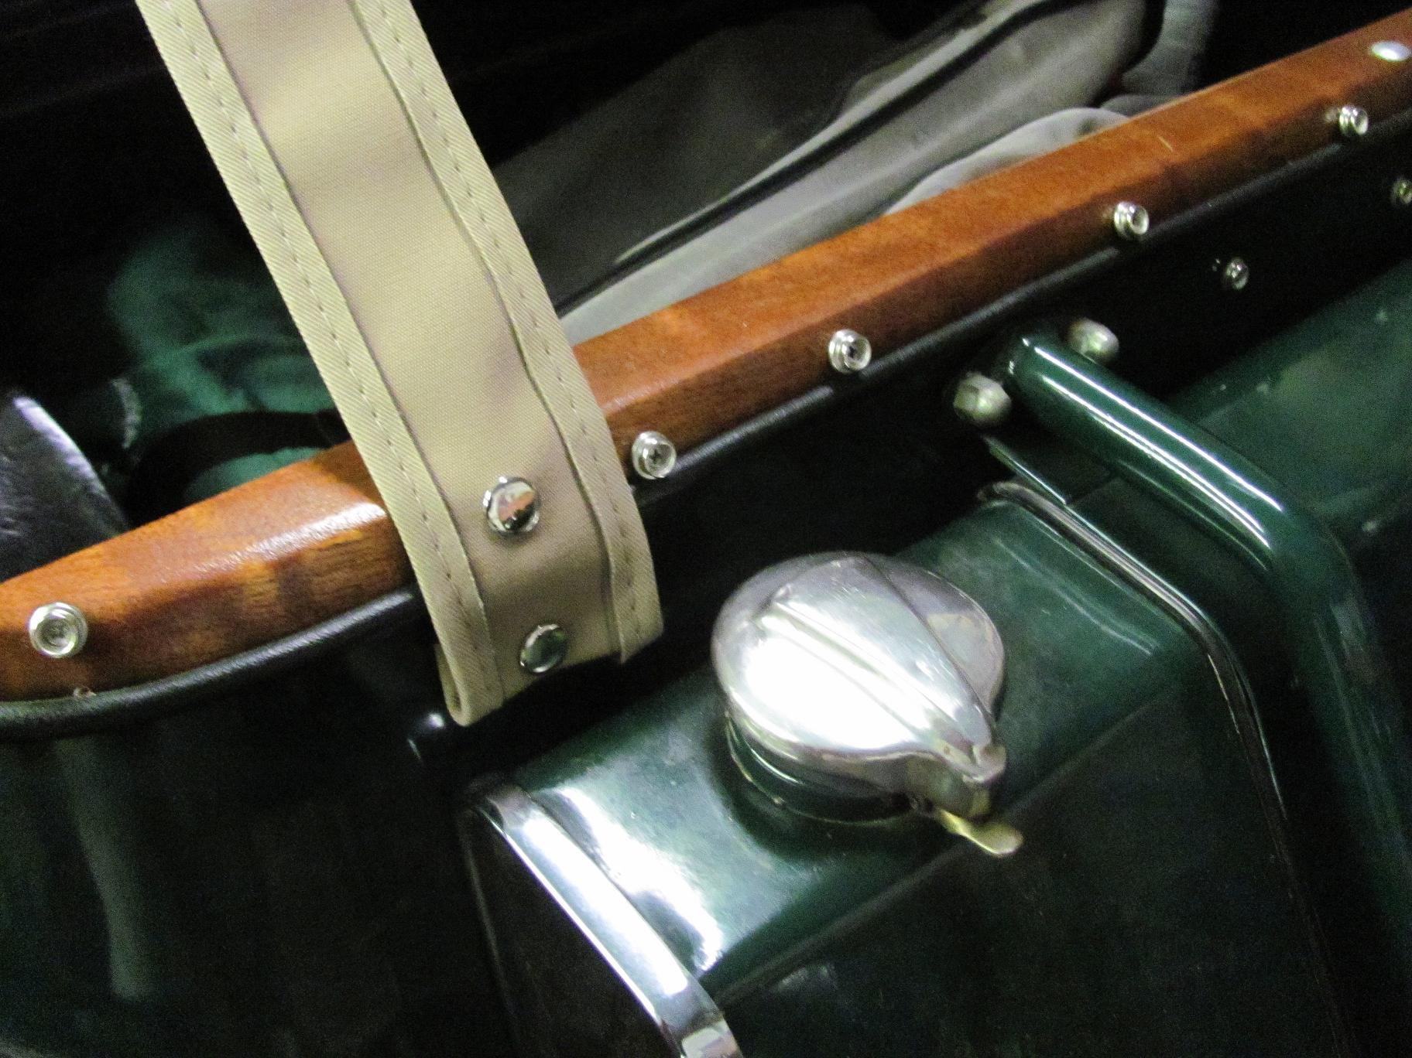

Now we’re on a roll and here’s what it looks like:
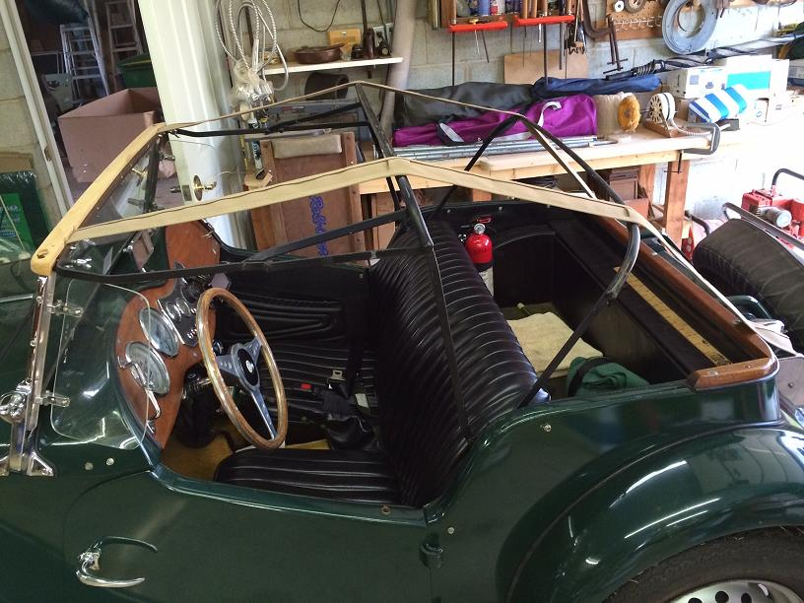

Installation of Hood Canvas – Rear
As mentioned above, I used snaps instead of screws to attach the hood canvas to the rear tacking strip. I probably should have gone to a boat store and gotten some perhaps higher quality SS snaps but I found convenient packages of snaps with wood screw male bases that included the punch, a guide and an anvil at my local Lowes so that’s what I used. I may have gotten carried away with the number of snaps installed but I just kept pulling out wrinkles and looseness and inserting snaps until it began to look pretty good. At this point the front of the canvas is not connected to the top rail over the wind screen so to give myself a bit of resistance while tugging on the rear to locate the snaps, I held the front of the canvas over the top rail and windscreen with squeeze clamps.
