Hood Fully Installed
The finished product. Note that mine is one of the rare single-wiper TDs ☺.
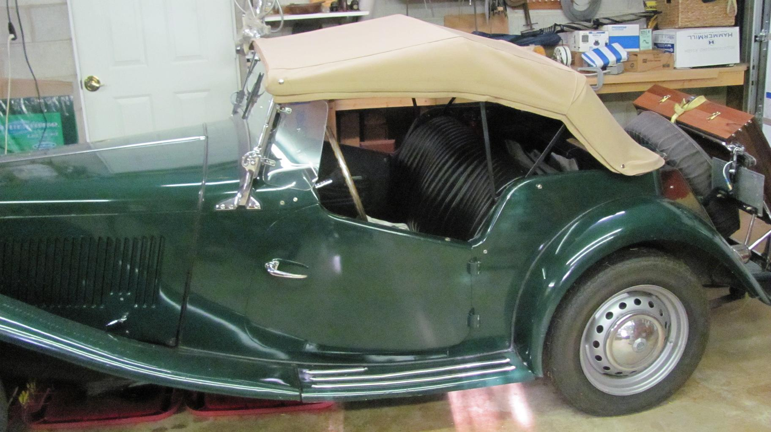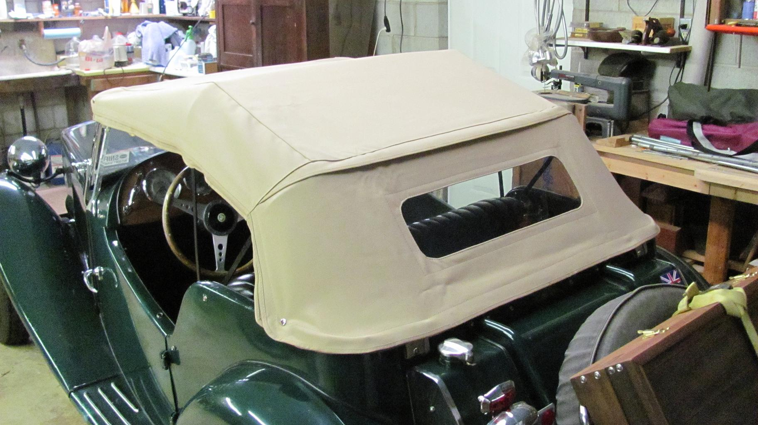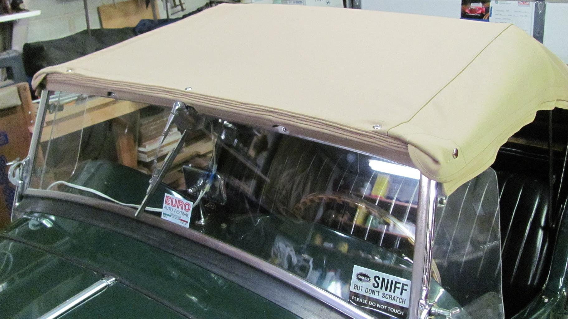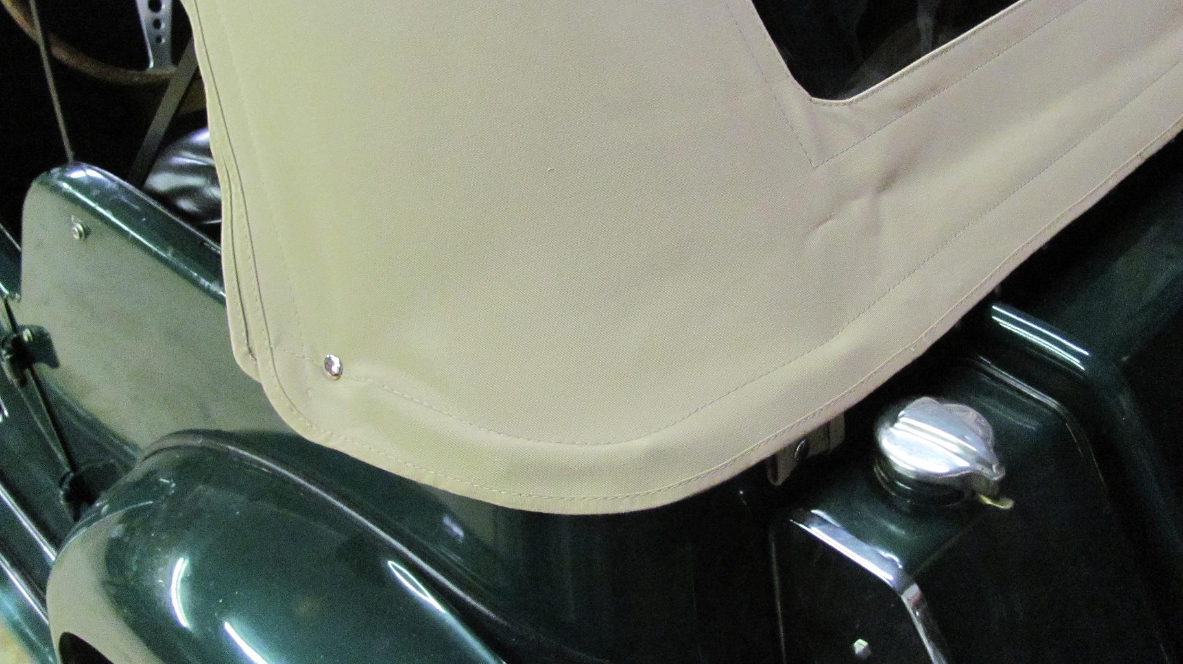

Removal and Storage
This process begins with unsnapping the rear and folding up the rear window.
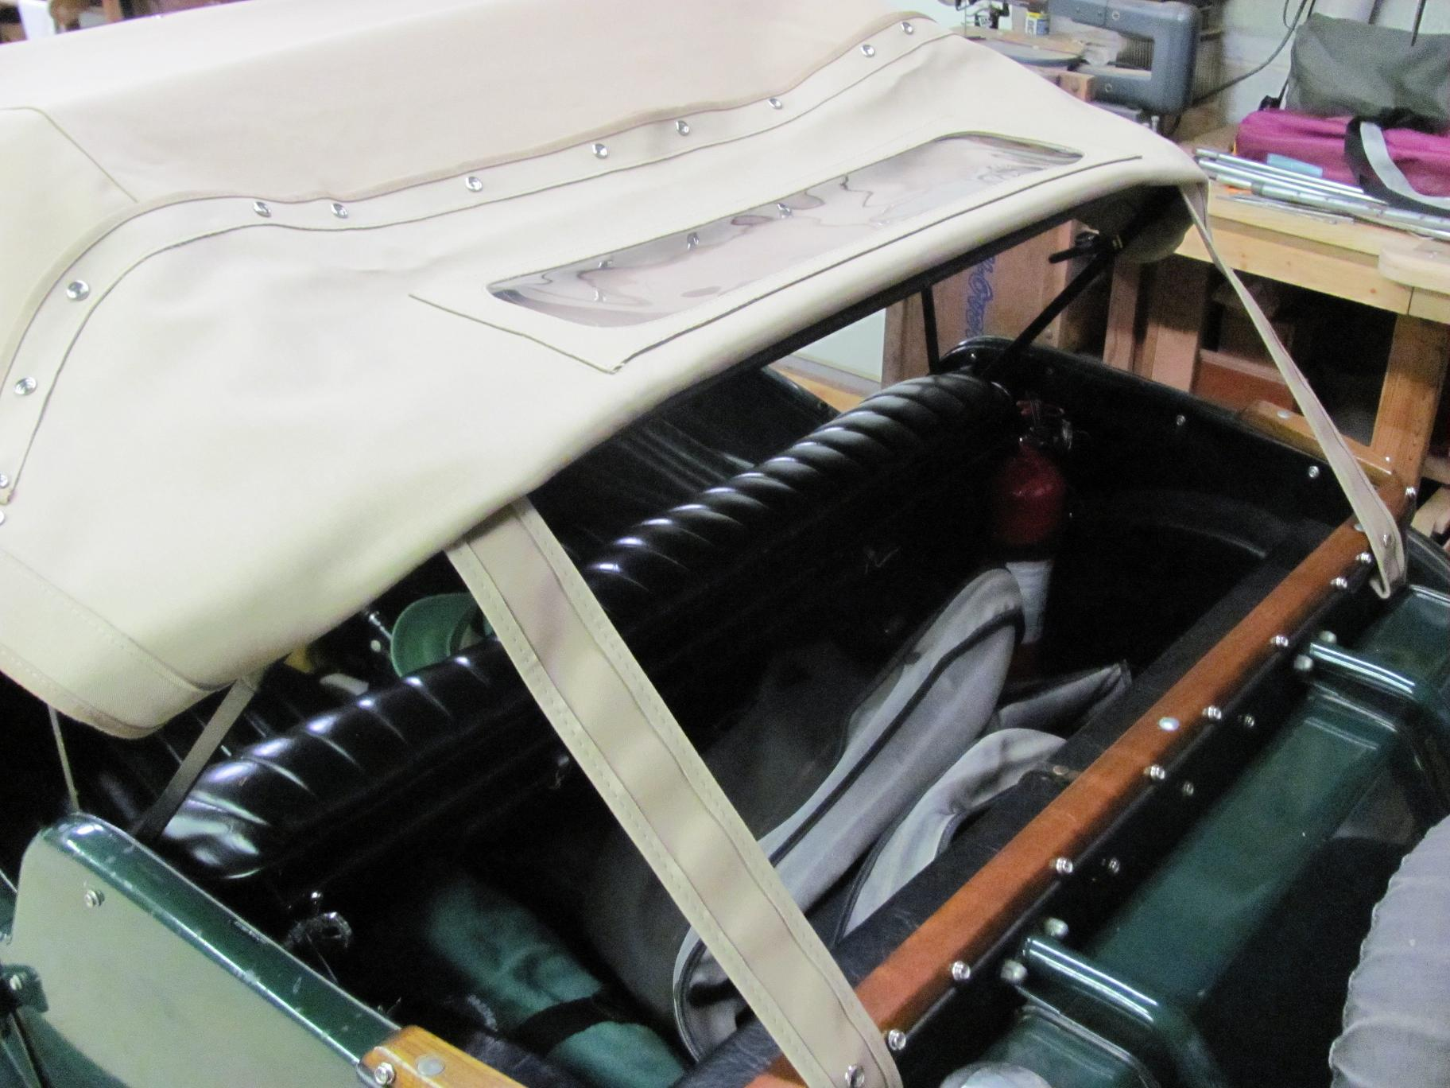

Next the canvas is disconnected from the top rail and folded back.
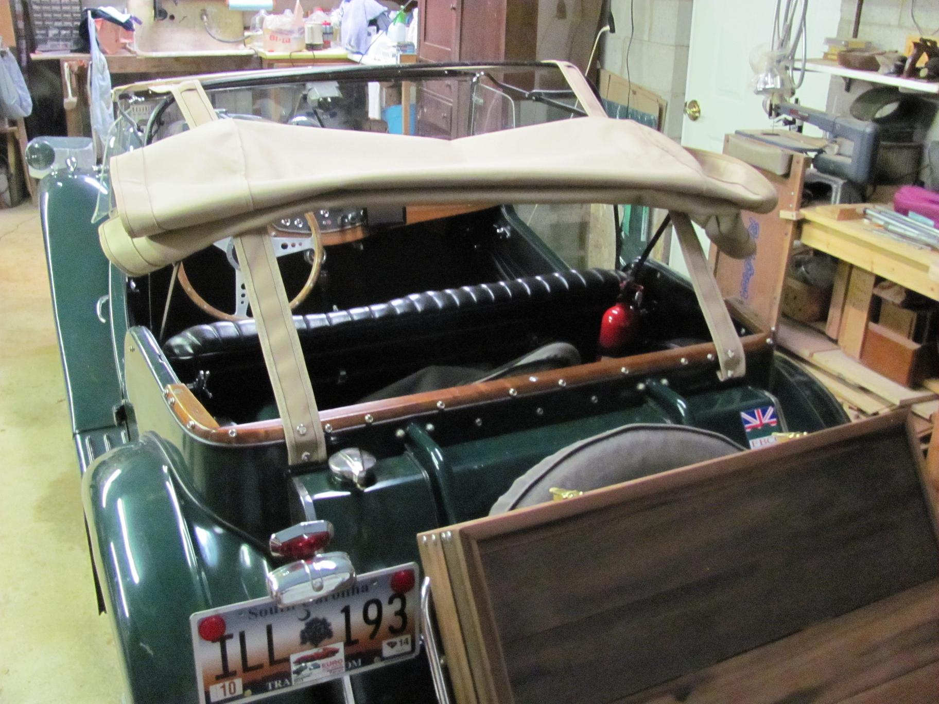

I had recently disassembled and replaced a hot tub made from 1-1/2” X 6” California Redwood staves so I resawed that wood down to ¾” boards for a frame and ¼” panels for the front and back of a storage box attached to my luggage rack. Here’s the folded hood ready to go into storage.
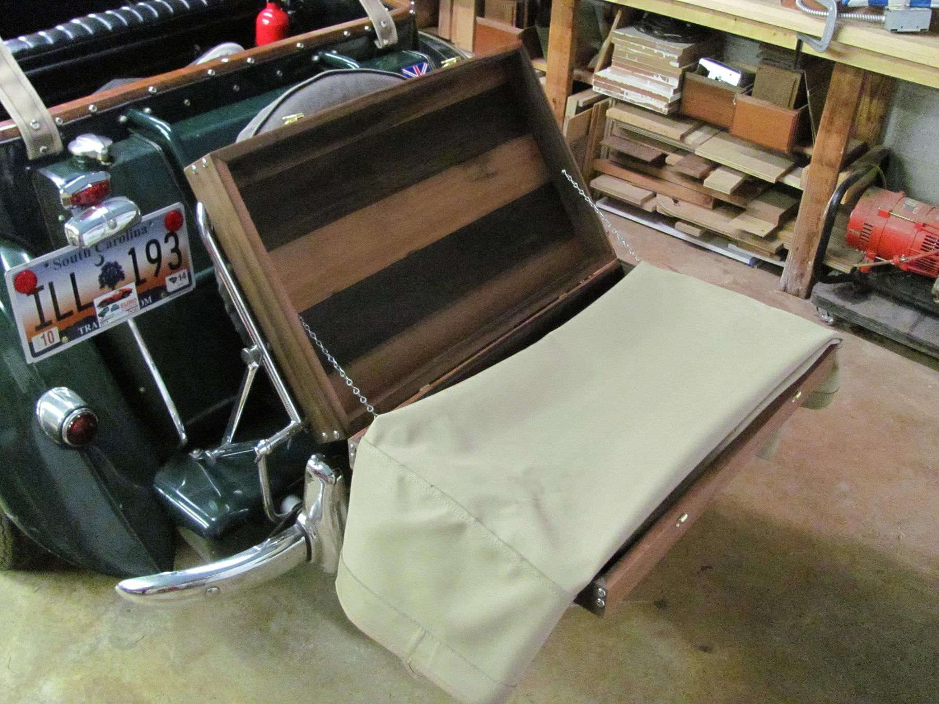

And here is it in the box.
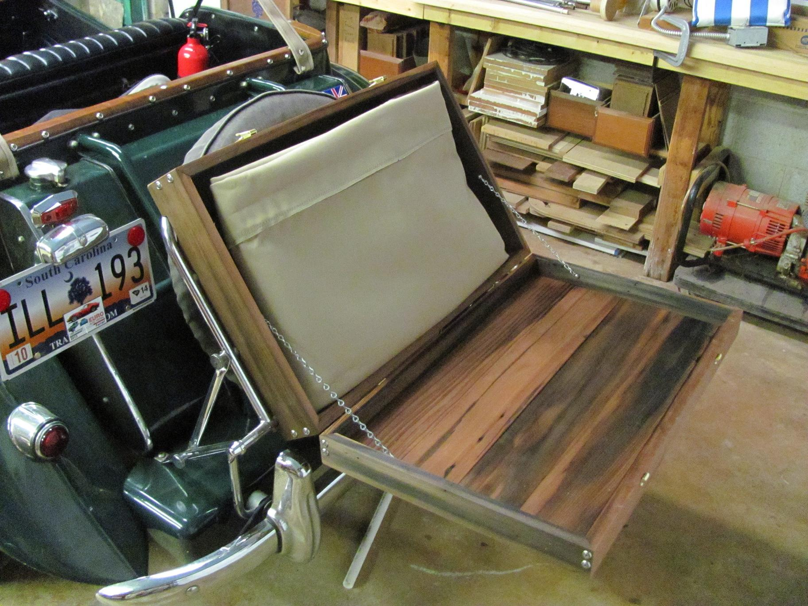

And closed up for travel.
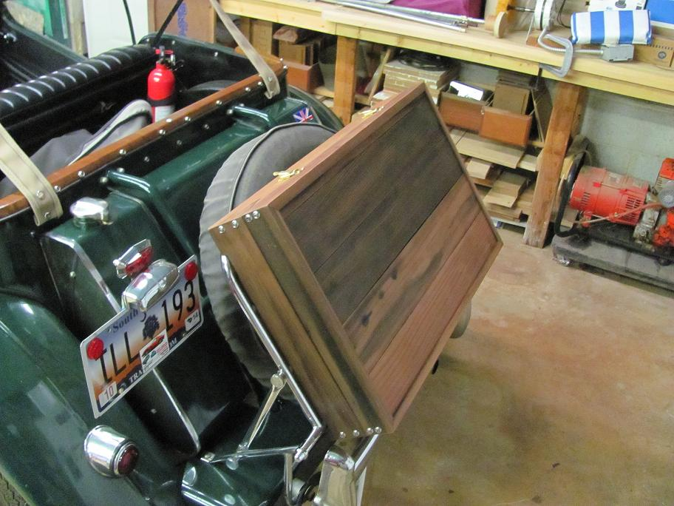

The lid of the storage box also serves as a convenient picnic serving table.

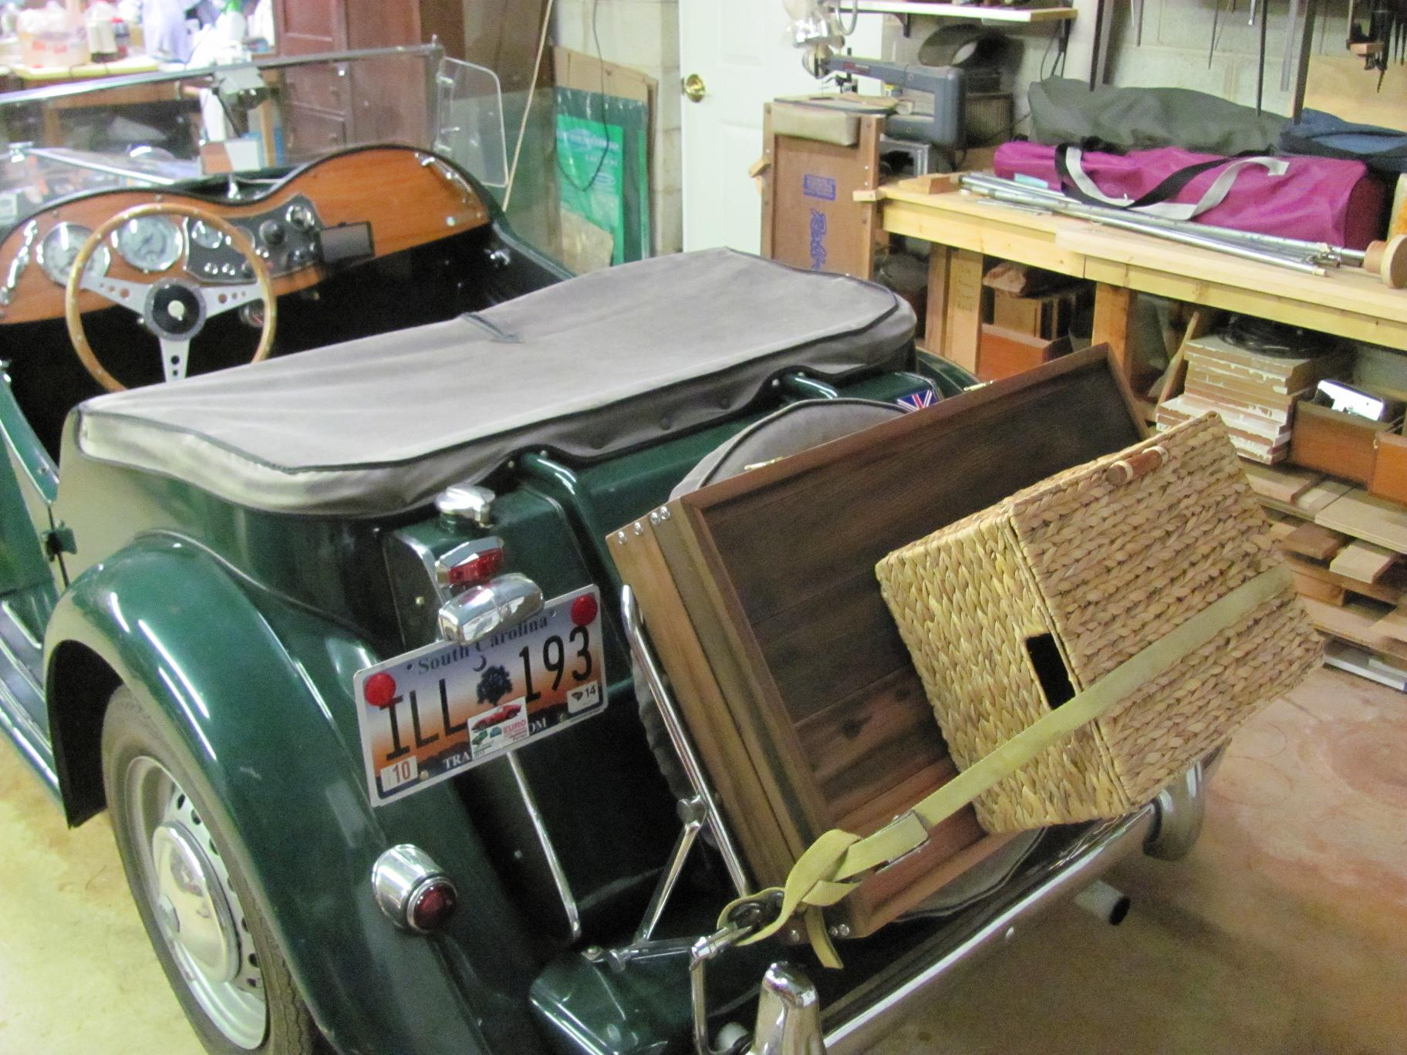

All in all I’m pretty happy with the results. Now it’s on the side curtains which I also hope to never have to use.

Jud

