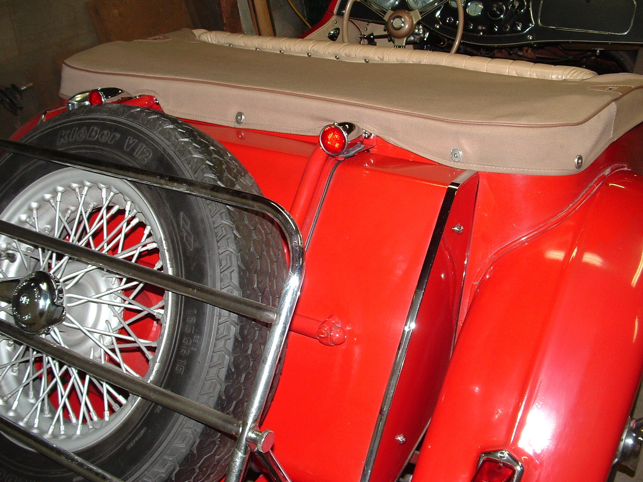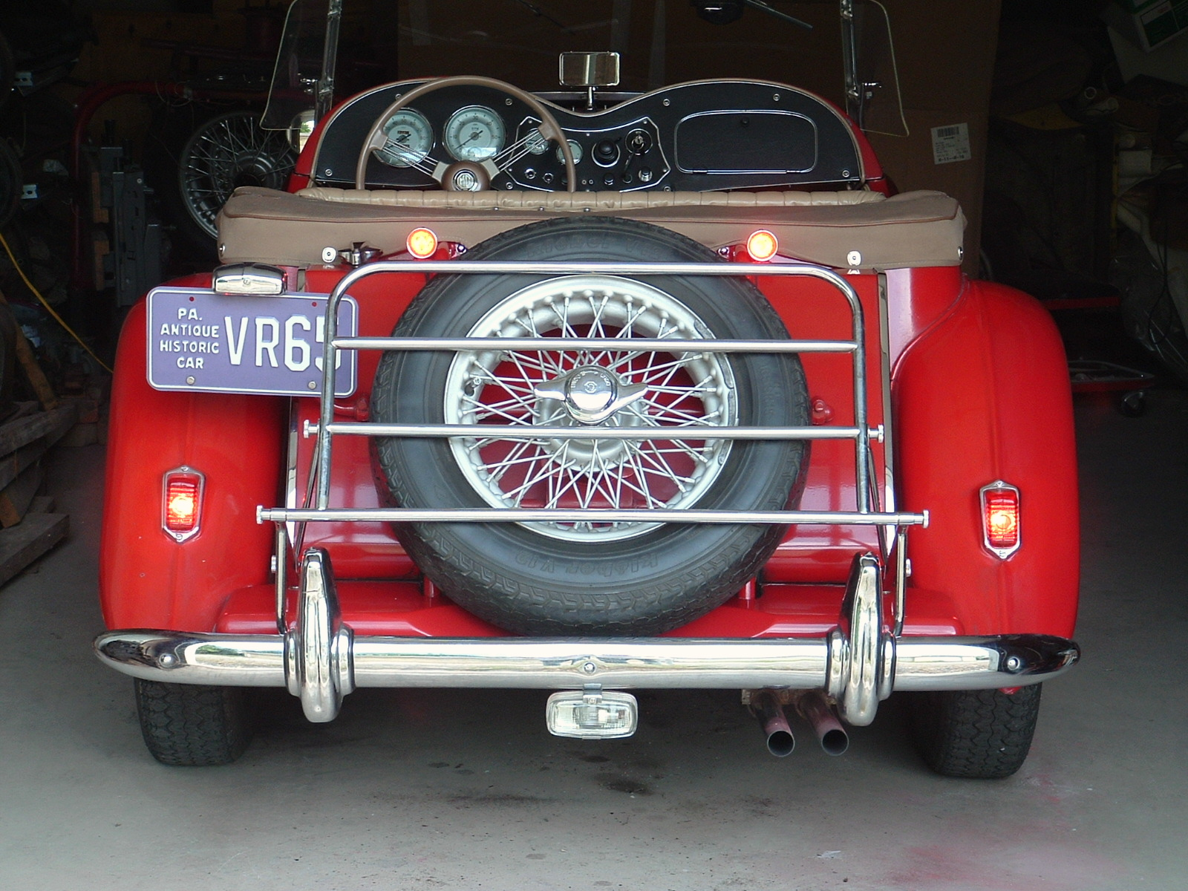
Finished Product Finished Product
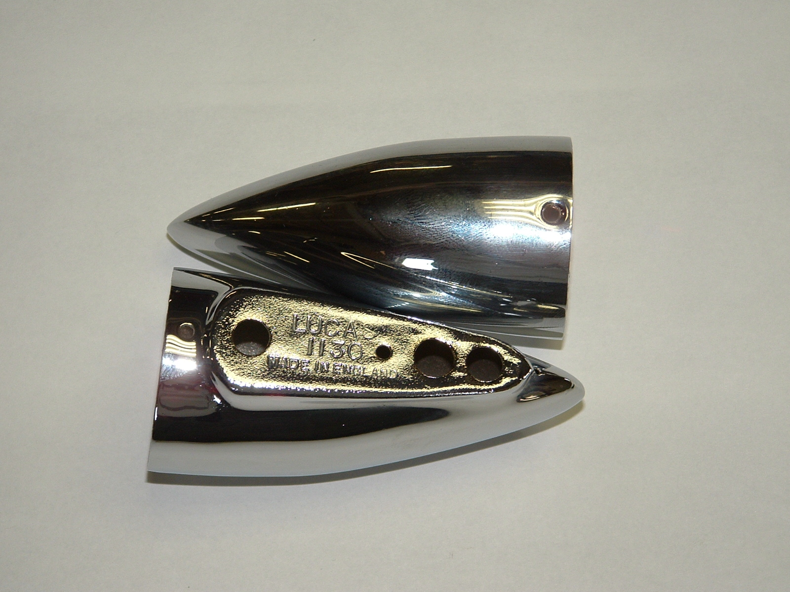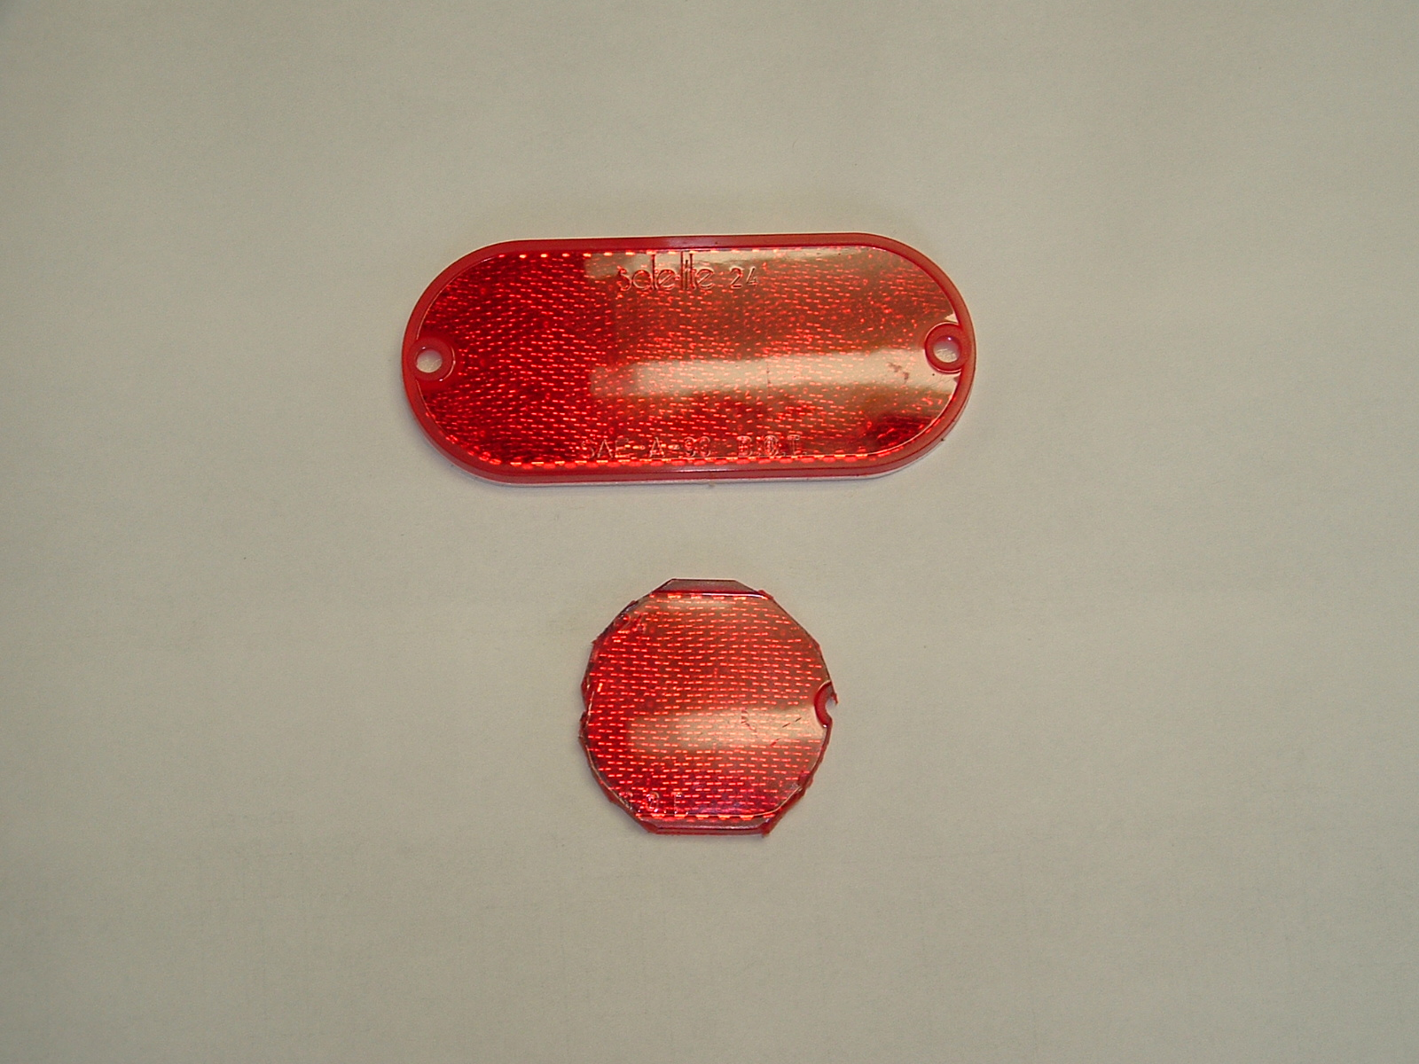
Lucas 1130 without red inserts Walmart reflector cut into circle
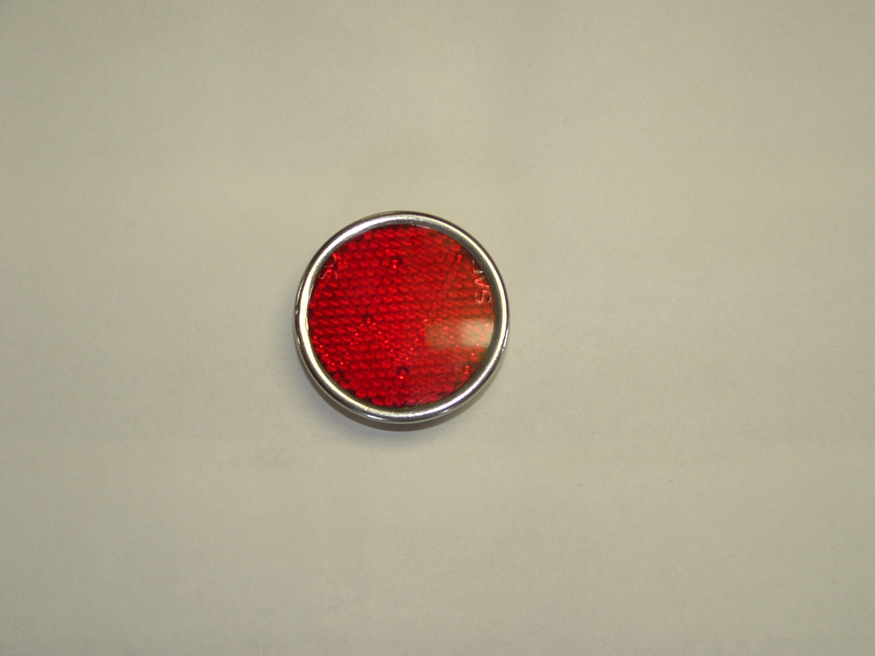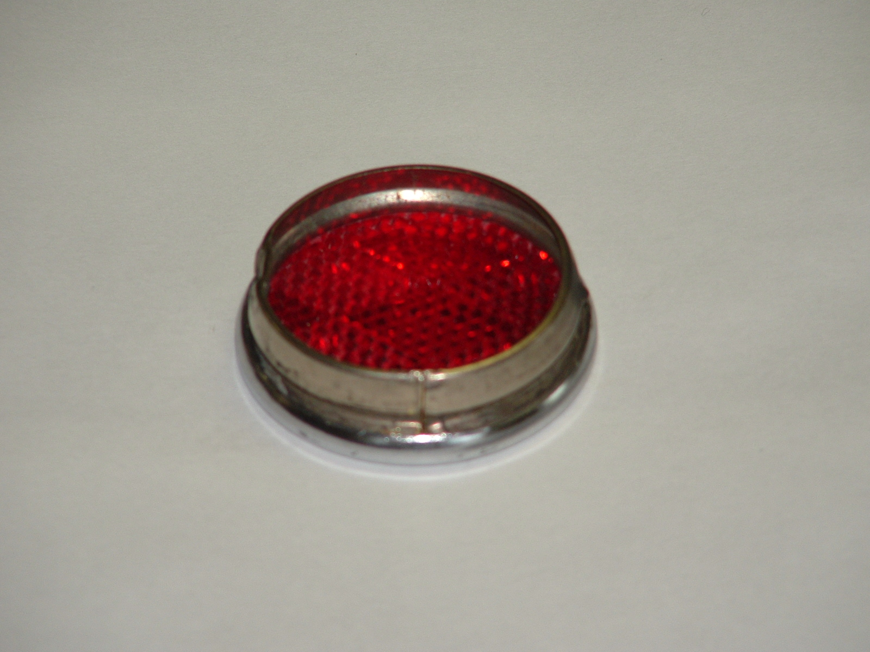
Reflector fit into chrome housing. Housing was cut to get it in.
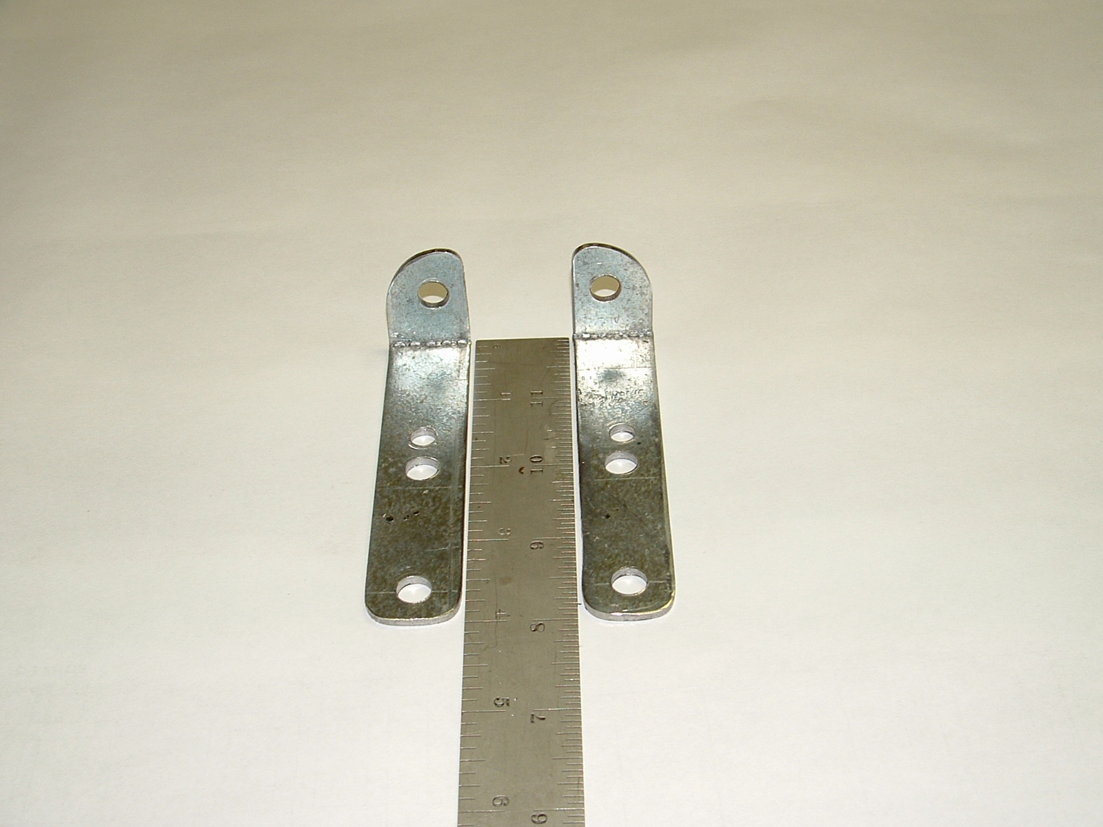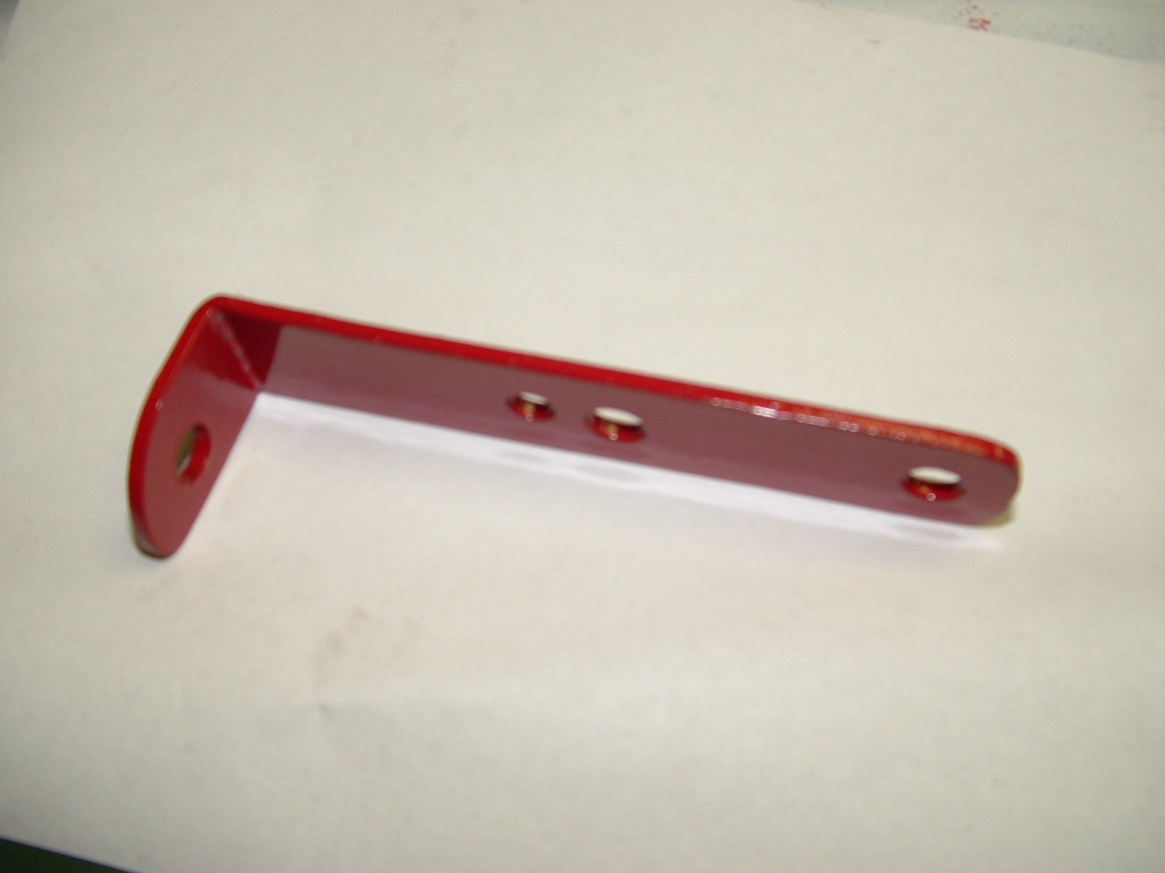
Brackets made to bolt onto spare tire carrier chrome acorn nuts, then painted body color.
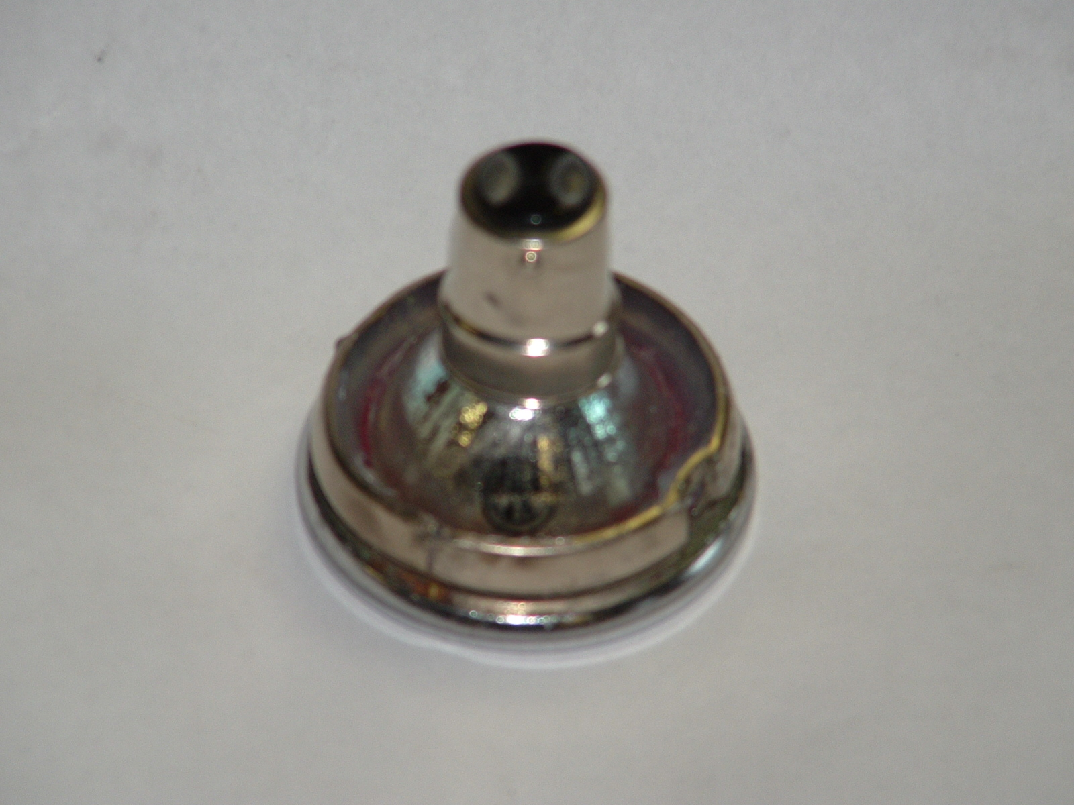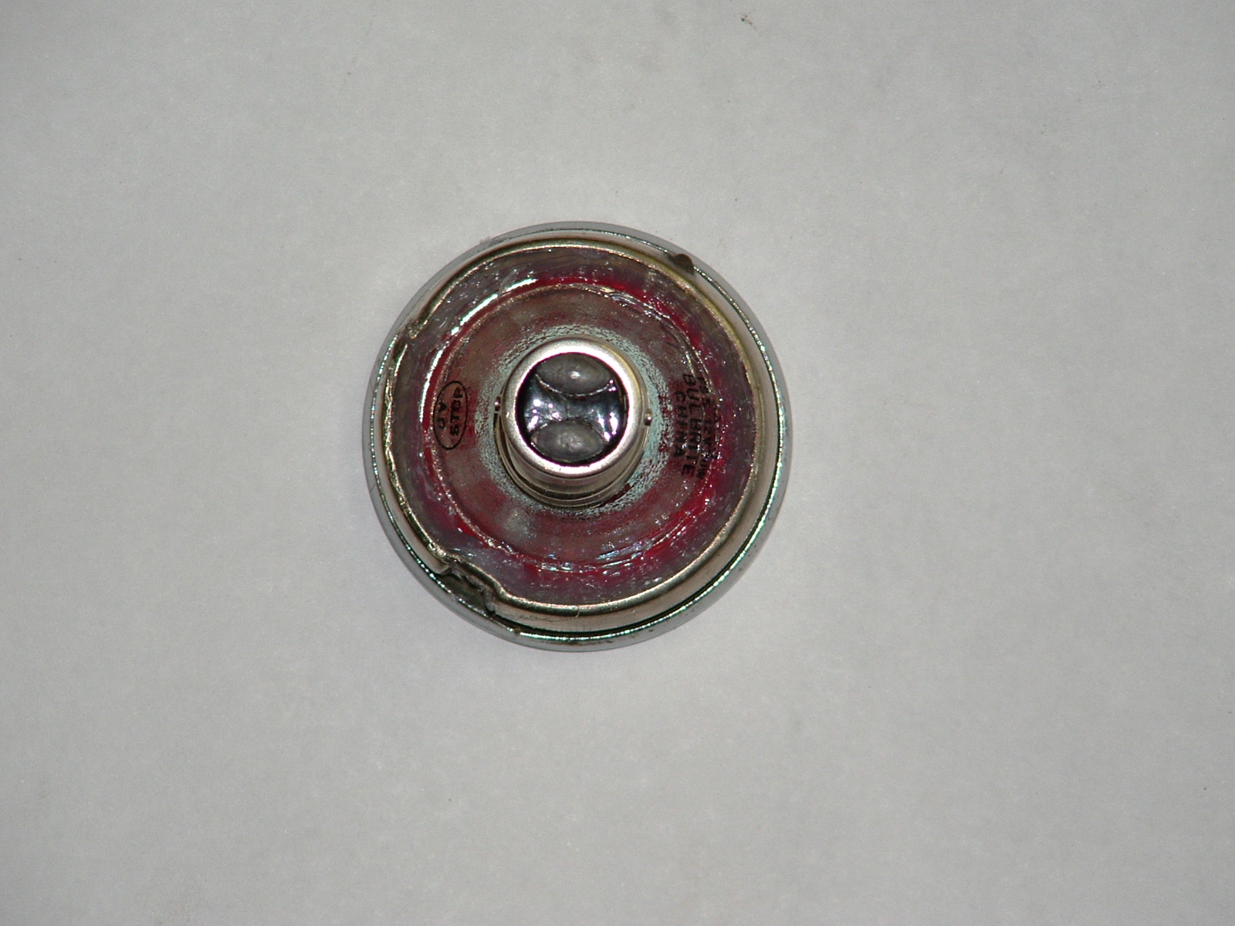
Bayonet base 12 volt MR-11 halogen spot light bulb glued in with clear silicone.
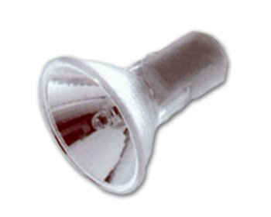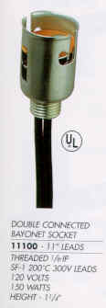
Bulbs and sockets from Pureland Supply over internet, Ba15d bayonet base. Additional searching may be required.

