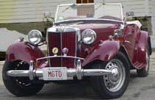
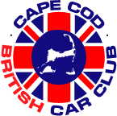

Ttalk
by Bud Krueger

An Artist Meets a TD
Sometimes I find myself in awe over what some others can do with their hands, and their imagination. One of these is a TD owner up north of our border, Gordon Lawson. Gordon is a staunch member of the Niagara British Car Club and has a barn find TD that he has been working on for a little while now. I can share that much with Gordon. As some of you may recall, I have a 53 TD that qualifies as the barn find variety. That's one polite way of saying that the car is a bunch of &^%$# that once was, and will someday once again be, a TD. Among the components of a TD that do not seem to age very well in the elements is the steering wheel. Original TD steering wheels are a beautiful thing with a rim that is an opalescent plastic. Here's a view of a part of Lazarus' wheel and what's left on 'the53'.
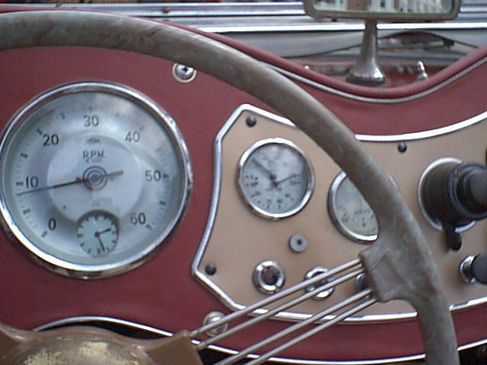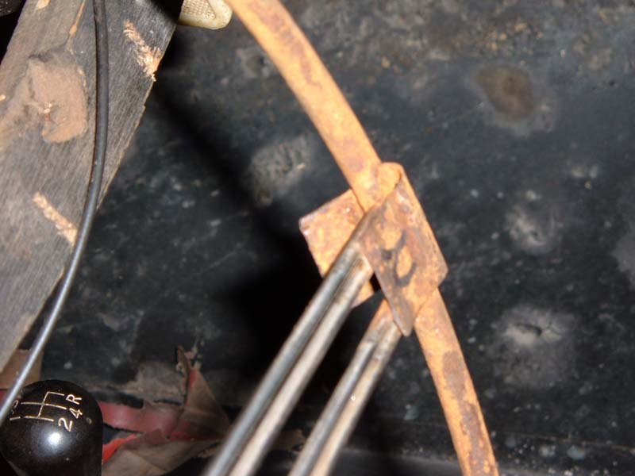

The bare frame from the53 view is about what Gordon had to work with when he decided to salvage the steering wheel from his car. Here's what he turned it into:
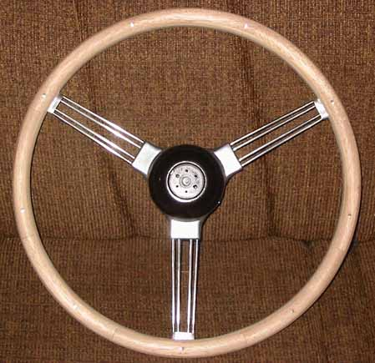

You can find the full story on how he did it by going to the Niagara Club's website at http://www.niagarabritishcarclub.org/gb/oldwheel/oldwheel.html .

At the time of this writing (mid December) Gordon has placed the wheel for sale on eBay. Seems that he's found a couple more in similar shape and plans to do it again.

