


Ttalk

Pertronix Igniters
Positive Ground vs. Negative Ground

Installation of a Pertronix Igniter into a Tcar is becoming a common occurrence. Not everyone agrees about the desireability of installing one, so I’m not about to get into a debate on whether or not one should do so. I’d just like to use a bit of ink to answer some of the questions about their use in positive ground cars versus negative ground cars. The Igniters are fairly recent devices and were developed with modern machinery in mind, hence negative ground is their basic configuration.

However, there is indeed a market for vehicles with positive ground systems. Not only our Tcars, but a lot of Detroit machinery was made that way a few years ago. The Pertronix Igniter is basically a very simple device and can readily be adapted to a lot of distributors. But, let’s stick to Tcars.

The basic, negative ground Igniter, is installed in place of the points and, for all practical purposes, functions just like a set of points. Inside of the module is a power transistor that operates as a switch. It is turned on and off by a clever device called a Hall-effect sensor that senses the presence of magnets in a rotating collar that fits over the distributor cam. The ‘top’ of the coil is still connected to the 12 volt (white) ignition wire and the bottom of the coil is tied to the module. During the dwell portion of the ignition cycle the power transistor is turned on current flows through the coil. At the moment of ignition the power transistor is turned off, current is abruptly terminated in the coil and the high voltage pulse is sent to fire the plug. Just like a set of points going from close to open. In fact, the wiring of a negative ground module is very much like a standard point ignition:
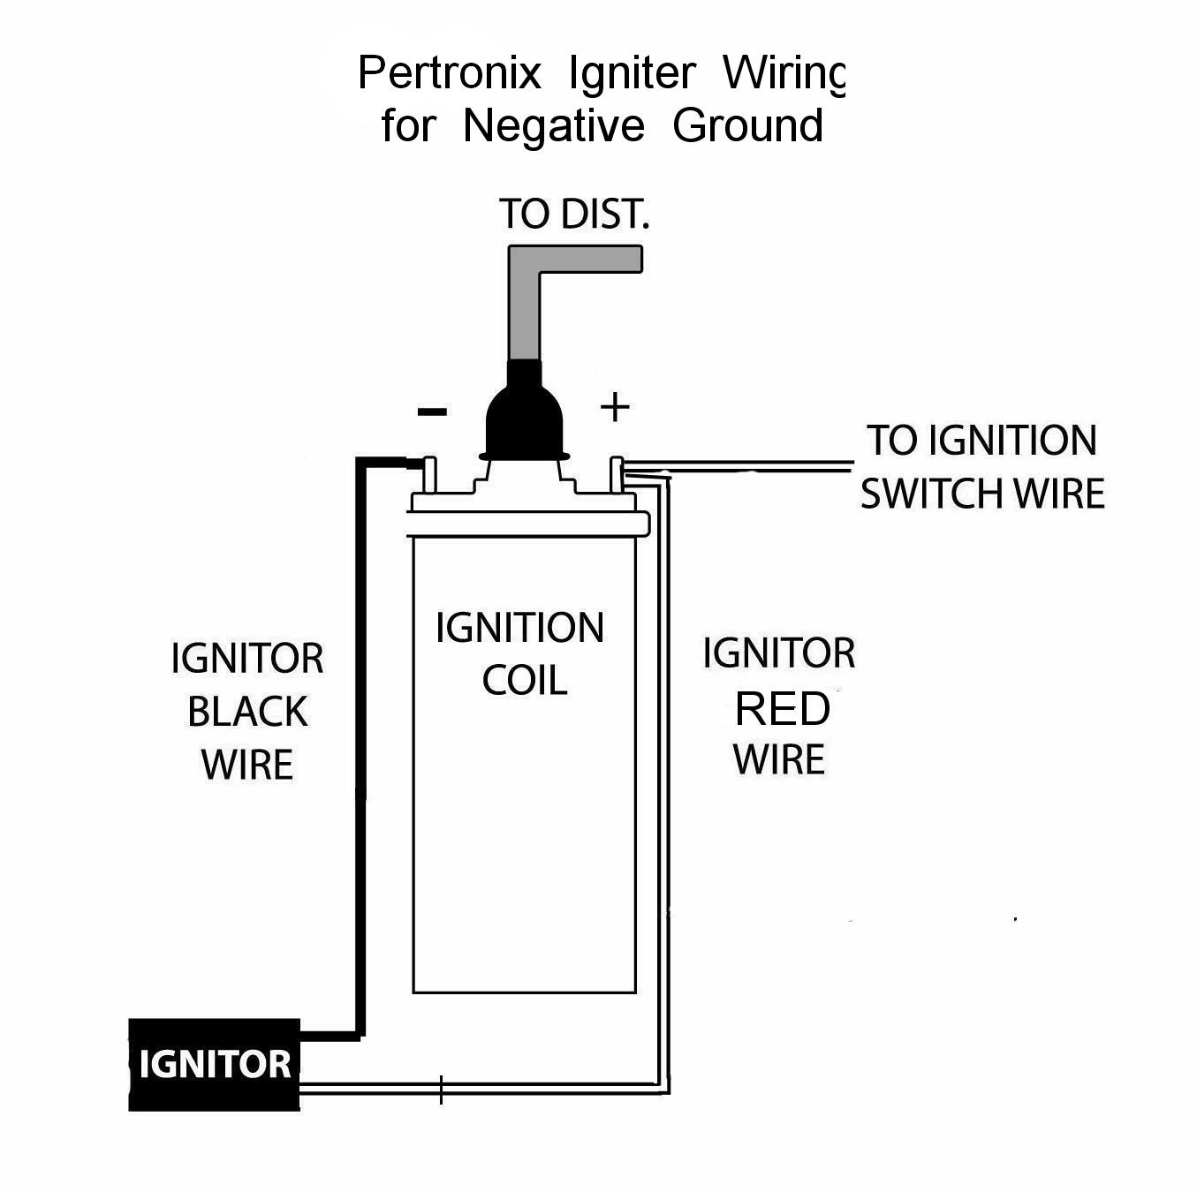
The thing that’s not obvious is the fact that the Igniter is a 3-wire device and depends upon the module being grounded through the distributor plate. Replacing the module with the original points plate is a very simple operation.

The positive ground module is a rather different kettle of fish. It still operates in the same manner, i.e., a power transistor is turned on and off by a Hall-effect sensor that is controlled by a magnetic sleeve. The big difference lies in the fact that the Igniter is connected to the ‘high’ side of the coil, i.e., between the coil and the –12 volt ignition wire. It still functions in the same manner. During the dwell cycle the power transistor is turned on and current is flowing through the coil. To fire the ignition the power transistor turns off and the coil generates the spark pulse. According to an engineer at Pertronix, many of the problems that users have with the positive ground modules are caused by users not believing Pertronix’ installation instructions and insisting on hooking up the module directly in place of the points. One of the first steps in installing a positive ground module is to connect a wire between the ‘bottom’ of the coil and ground, or earth if you prefer. Here’s what the installation looks like schematically:
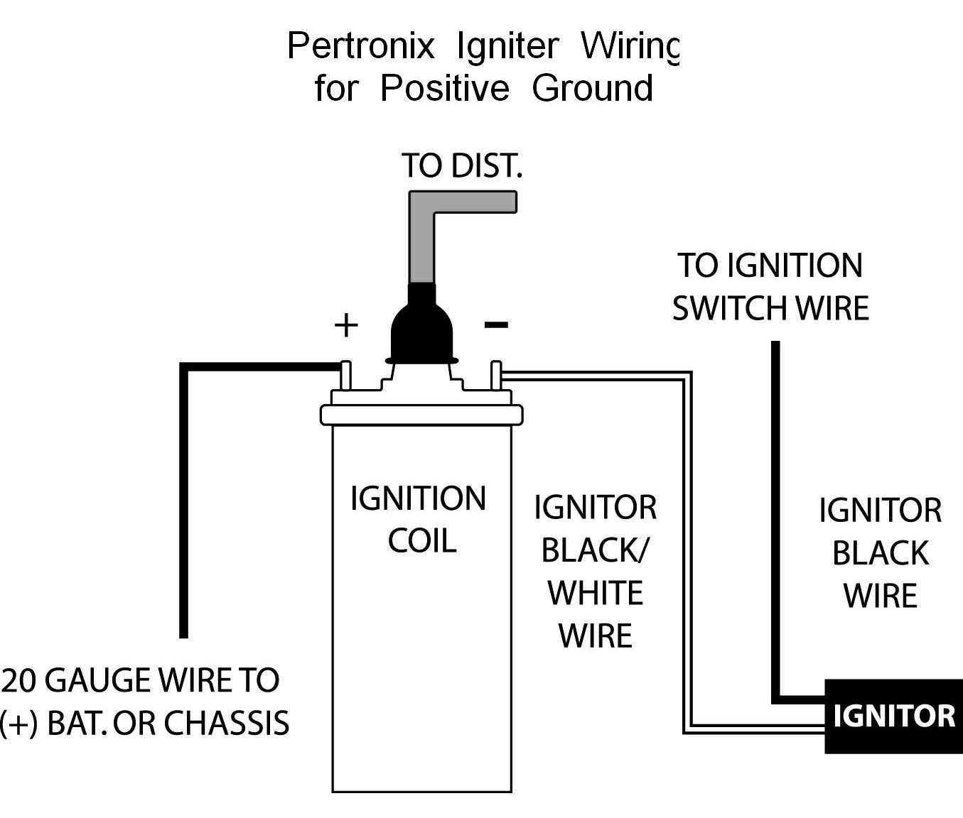
So there you have it. More detailed information, including the step-by-step installation of an Igniter into Lazarus, my negative ground TD, can be seen on my website, www.Ttalk.info. There you can also find instructions for how to test both types of modules. All the usual disclaimers apply here about financial interests. My experience has been that Skip Kelsey of Shadetree Motors is an excellent source of Pertronix modules and can be a big help in deciding which module you might want. Skip Kelsey is at http://www.shadetreemotors.com. Besides negative and positive ground issues there’s also the question of symmetric, asymmetric or high-lift.

