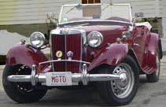


Ttalk
by Bud Krueger
.
LED High Mount Brake/Turn Lights

This information is being shown for the sole purpose of showing what I've done to my TD to give me some degree of protection from drivers who may have difficulty seeing Lazarus' low tail lights. I have no idea as to the legality of this modification, so I certainly don't suggest that anyone else follow my example.

I'd been looking for a reasonably priced (read cheap) way to install a pair of LED light bars for use as high mounted brake and turn signal lights. An ad from JCWhitney came along with a price that was low enough to tempt me ($6.99). I ordered a pair of them for $20.97 including shipping. (JCW #124336)
Each bar contains 16 red LEDs behind a red plastic filter and is about 6" long and 1.5" wide. It took a while to figure out a way to mount them onto the back of the TD so as to be visible from behind the car and up high enough to be seen in traffic. What I decided to do was to make an adapter that would be held in place by the bolts that secure the fuel tank straps to the tub. The ends of these bolts (2 per side) are normally capped off by chrome acorn nuts. A trip to Home Depot came up with a piece of 1/16" thick aluminum angle stock, 1" on a side.
I discovered that the fuel tank bolts are 2" on center and the bracket is about 3" wide, so I cut a couple of notches in the bracket on 2" centers. I did this by drilling a pair of 11/32" holes 3/16" up from the edge and then use a file to create the notches. You can avoid scratching the tub if you slip the adapter between the fuel tank strap and the spare wheel carrier. There's plenty of thread left on the bolt so that the 1/6" will have negligible effect. I later discovered that I had to remove some material to allow room for the tonneau cover to slip behind the light.
It was necessary to move the LED bar out a bit on the bracket to space it away from the tub wood, otherwise it interferes with the lower edge of the hood. Another lesson learned was that the back wall of the tub is not vertical. I had to bend the top surface of the mount by what I estimate to be 10 degrees. Here's what the assembly looks like, and installed:
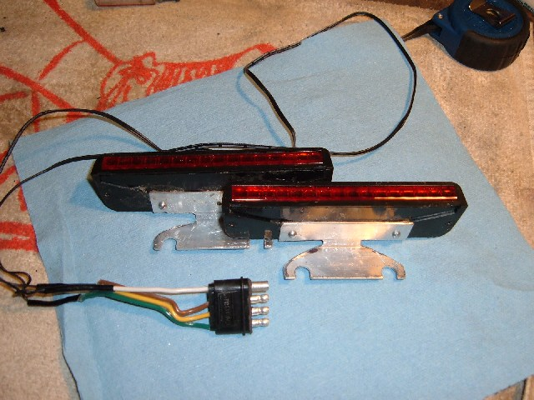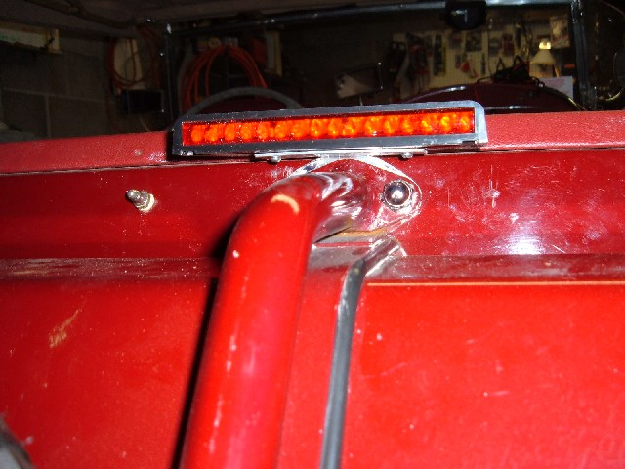
Wiring is simply tucked into the shelf covering and connected up to a cable that runs down to the rear wiring bundle under the car. I've set mine up with a standard trailer connector.
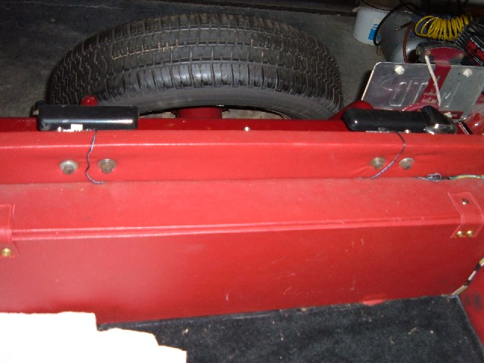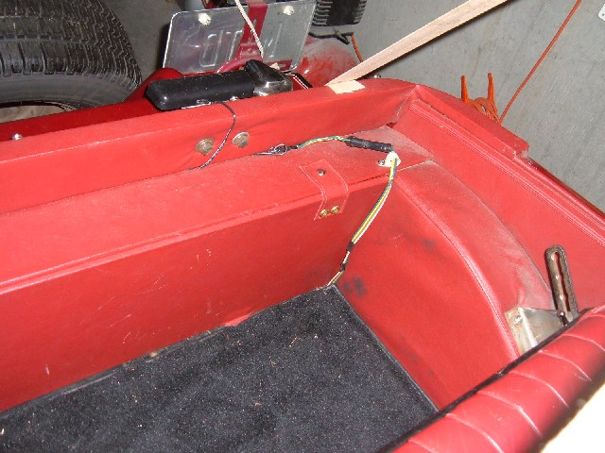
What's the effect? As expected, they're very bright, but quite directional.
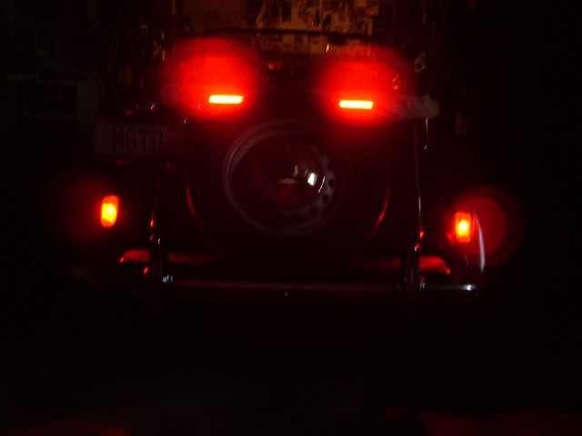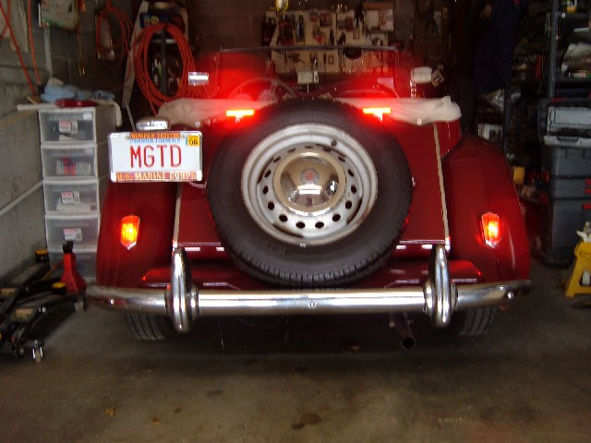
How much current do they draw? About 1.42 amps total for the pair, about 44 mA per LED. Since they are standard 2-wire LED devices they can readily be wired for either positive ground (gray/black wire common) or negative ground (black wire common). For more detail see my webpage http://www.ttalk.info/led_high_mounts.htm. You might also want to see http://www.ttalk.info/Tech/HighMountLights.html for another solution to the visibility issue. I must admit that the LEDs do look a lot neater.
Bud Krueger
admin@ttalk.info

