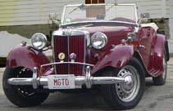
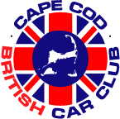

Ttalk
by Bud Krueger
Hans Across the Water --- Encore!!

Excuse me if I digress from my usual T-series orientation for this month and expand my horizons. I've recently had the opportunity to be invited to play a part in an event that shows the broad reach of our involvement in the world of lbc's, especially MGs.

I'm sure that many of you participate in some form of internet forum connected with our cars, I've been part of the mgs group on the autox.team.net site. This site is populated mostly by owner/drivers of MGs, but anyone can participate. The site is populated very much as the world of MGs is, i.e., members from around the world. But -- there's that common bond that hooks us together, we're hooked into MGs.

This universality was brought to the fold about six years ago when a member of the list, Hans Duinhoven, from the Netherlands let it be known in December of 1999 that he was coming to the Boston area for training in early January and would enjoy meeting other listers. That's all it took to get the ball rolling. On Sunday, January 9, 2000, about a dozen of us met at the historic Wayside Inn in Sudbury, Massachusetts and had lunch with Hans.
In the course of many emails it seems that the event needed to have a theme. With apologies to the Beetles it became known as Hans Across the Water. More details of the event can be seen on my website at http://www.ttalk.info/hans2.htm.

Over the past six years we've occasionally made contact and talked about doing it again 'one of these days'. You know how those things go. Well, it turns out that Hans recently changed employers and his new employer decided that he should go to the Boston area for some training. After a few weeks of climbing in and out of cyberspace we were able to put together that which was called 'Hans Across the Water - Encore'.

On Saturday, May 6, we again met with Hans at Longfellow's Wayside Inn and had a wonderful time. Some of the original group weren't able to join us this time, but we were joined by some great new folks. Here's the group (minus yours truly)
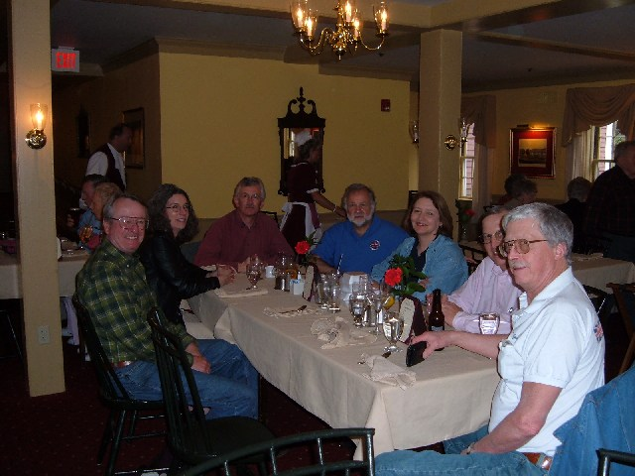
Coming around from the left we have Paul Hinchcliffe (about to become President of CCBCC), Denise Thorpe (known to many as the Goddess of the list), Hans himself, Frank and Linda Krajewski of BMCNE fame and Alex Gottfried (54 TF from Sudbury, MA). No, I haven't forgotten about the one at the close end of the table. He was the absolute surprise of the whole event. For those of you who are members of the mgs list I would like to show you the face that belongs to the list curmudgeon, none other than the irascible Ed Kaler of JustBrits. Ed flew in from Chicago just to join in the celebration of Hans' encore and to bug yours truly.

You are invited to see more about the event by aiming your computer to http://www.ttalk.info/Hans2.htm . It was indeed an MG day. Hans got a ride in Lazarus (my TD), Paul Hinchcliffe's TC, helped with a Pertronix installation in Alex's TF and tried to polish Denise's MGB. You should have been there to join us. Maybe next time.

admin@ttalk.info

