


Ttalk
by Bud Krueger

What's in Your Radiator?

My apologies to the credit card outfit for stealing a bit of their line, but it's the season. Ambient temperatures here in New England have already touched the 90's. It was barely a week ago that Lazarus got caught in one of those inevitable traffic jams while trying to cross the Sagamore Bridge and get off of Cape Cod on a summer Sunday. As I inched along I watched the water temperature needle do its slow creep upward. Like the sands of time on the calendar. Out of the 80's. Into the 90's. Sure do hope that the new century doesn't show up! By the time I got over the bridge the temperature had crested at about 93C.

Just a few anxious moments, but long enough to again ponder that age old question -- 50/50 or plain water? Say what? We tend to think of anti-freeze as being just that, a chemical that we put into our cooling systems to prevent it from freezing in the winter time. We know that a 50/50 mixture of Prestone and water gives protection down to -35F. It also works at the other end of the spectrum -- it raises the boiling point of the coolant. Indeed, a 50/50 mix of Prestone raises the boiling point to 223F, an increase of 11 degrees. (This is for an unpressurized cooling system.) What's the price that we pay for this, the downside? Ethylene glycol antifreeze isn't as efficient an absorber or radiator of heat as is plain old water. A 50/50 mix has only about 83% of the heat capacity of plain water.

So, the issue is -- should one run with plain water (plus a bit of Water Wetter) and hope to stay cool, or should one run with 50/50 and know that you can go beyond the century mark without emulating a Stanley Steamer? A couple of years ago, after inching along for a couple of hours in a July 4th parade, here's what my temperature gauge looked like:
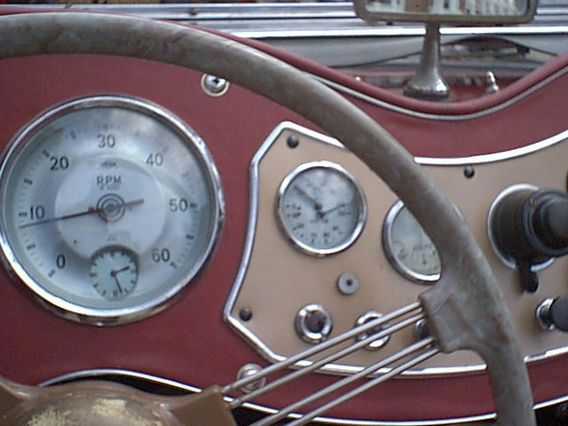
Notice the temperature gauge needle showing a wonderful oil pressure reading! Fortunately, I was using the 50/50 mix at the time, so I wasn't blowing off steam. The big question is --- would the reading have been on the other side of 100C if I had been running with plain water? Sure do wish I knew for sure. This year I think I'll try the 100% water route (plus a few ounces of Water Wetter). I'll let you know what happens.
(BTW, I opened the side of the bonnet for about two minutes and the temperature dropped back where it belonged. No ill effects. Have a safe 4th.)

