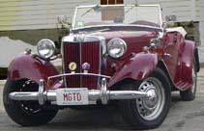


Ttalk
by Bud Krueger
A TD MKII Puzzle

Late last Fall a fellow CCBCC'er, Les Frank, asked me to have a look at his 1952 MKII TD. He bought it from someone in Florida and it just didn't seem to have much pep and he figured that it was running too rich. In reality, it could barely get out of its own way. I'll swear that every other TD owner that I run into now days has a MKII. I was about ready to figure the same thing a bout Les' until we popped open the bonnet. Sure enough, there were a pair of SU fuel fumps feeding a pair of H4 carburetors:
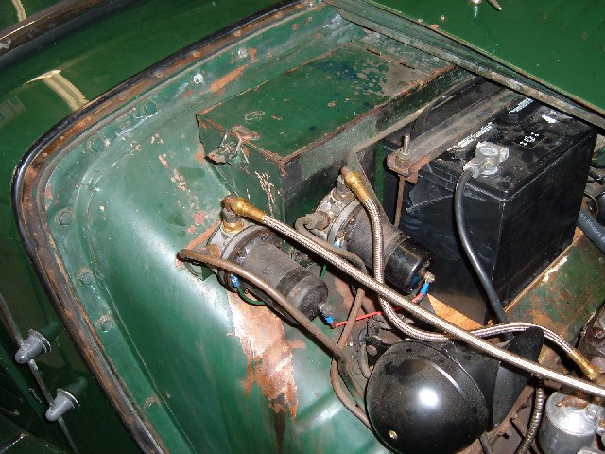
Something just didn't seem right about the setup, but couldn't put a finger on it. There a number of oddities about the car, one of which almost bit me. Going about the normal routine of starting a TD I reached inside and grabbed the choke knob to pull it out. Fortunately, I had my other hand free and clear of the engine --- the starter control is where the choke control should be!!! Once I caught my breath and counted my fingers, I suggested to Les that he should put the controls back where they belong. I manually actuated the choke linkage and started the engine. A bit rough, but it wasn't too bad at idle. However, it wouldn't pull for beans when on the road. Played with the jets for a bit and decided that it needed more than that. It just so happens that I had rebuilt the carburetors from 'the53' and agreed to loan them to Les while I saw what I could do with his MKIIs.

It wasn't until this Spring that I got around to digging into the MKII carbs. I went ahead and ordered a bunch of parts that I figured would suffice to refresh a pair of MKII carburetors. I then set up my work bench with Les' carbs and my SU Rebuild video. All of a sudden I found myself looking at parts that just don't belong on a MKII carburetor. After sending a few images off to Lawrie Alexander, the SU guru of the Moss video, I discovered that I was looking at a pair of MGA carburetors masquerading as a pair of MKIIs! One strong hint was the MGA fast idle choke control cam that doesn't belong on a MKII:
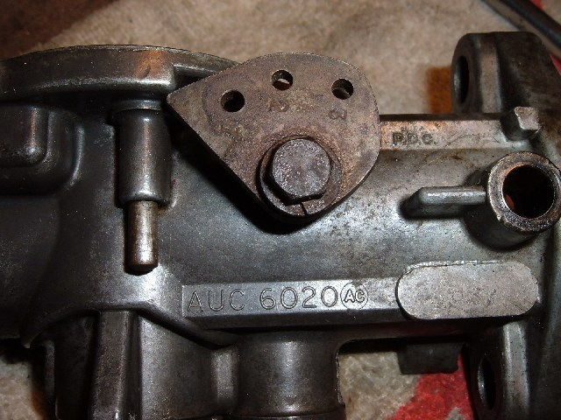
Note the casting number, AUC6020. A MKII should have AUC6021 and AUC6030. The AUC6020 is the right number for an MGA 1500. They are very similar to the TD MKII, but need a few modifications if they're going to fill the role. The choke linkages are virtually interchangeable. The cam shown here must be removed and the hole plugged with a 6mmx1 screw. On the other (TD front) carburetor it was necessary to drill and tap a casting boss in the mirror image of this cam pivot. It was also necessary to replace both throttle shafts and drill/pin them to take the MKII throttle stops as shown here
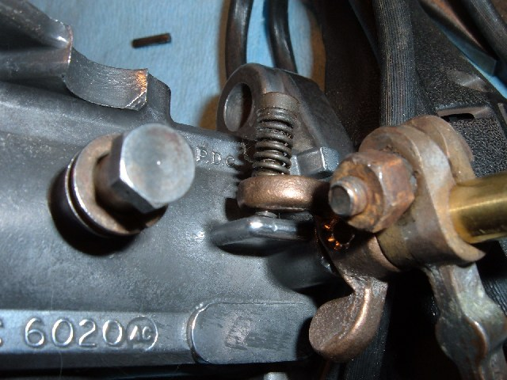
About that same time it was seen that the throttle shaft bushings were worn to the point of needing replacement. By the time I was finished I had created a virtual pair of MKII carburetors. Before taking them back to LES I was going to have to give them a real test to make sure that they really work.

Actually, I'd been curious for some time as to whether it would be worth my while to convert Lazarus (my 52 TD) to a MKII carburetor configuration. The engine is internally beyond MKII specs. I installed the carburetors, with their manifold, on Lazarus and tried a variety of driving tests to see if I could tell the difference via seat-of-the-pants. The answer is unequivocally --no. The H4 carburetors gave no noticeable difference in the performance of my TD.

The carburetors have since been reinstalled in Les' car and it still doesn't want to get out of its own way. Last I heard, Les had discovered that his problem is with the distributor and wiring. Lawrie Alexander has been known to make the statement that "90% of the trouble with SU carburetors is from the Lucas electrics". Another indignity that Les' MKII has suffered is that his original MKII engine has been replaced by an early, 4-digit, one.
More details on this MGA/MKII modification can be found on my website by going to http://www.ttalk.info/TDMKII.htm.

Bud Krueger
admin@ttalk.info

