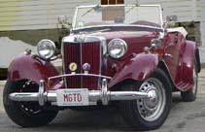


Ttalk
by Bud Krueger
Modern Oil Filter for Late TDs/TFs

From 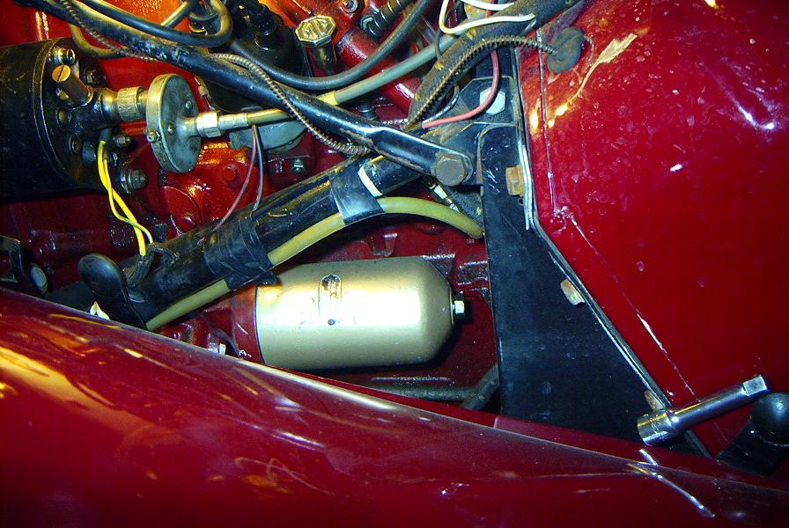 to 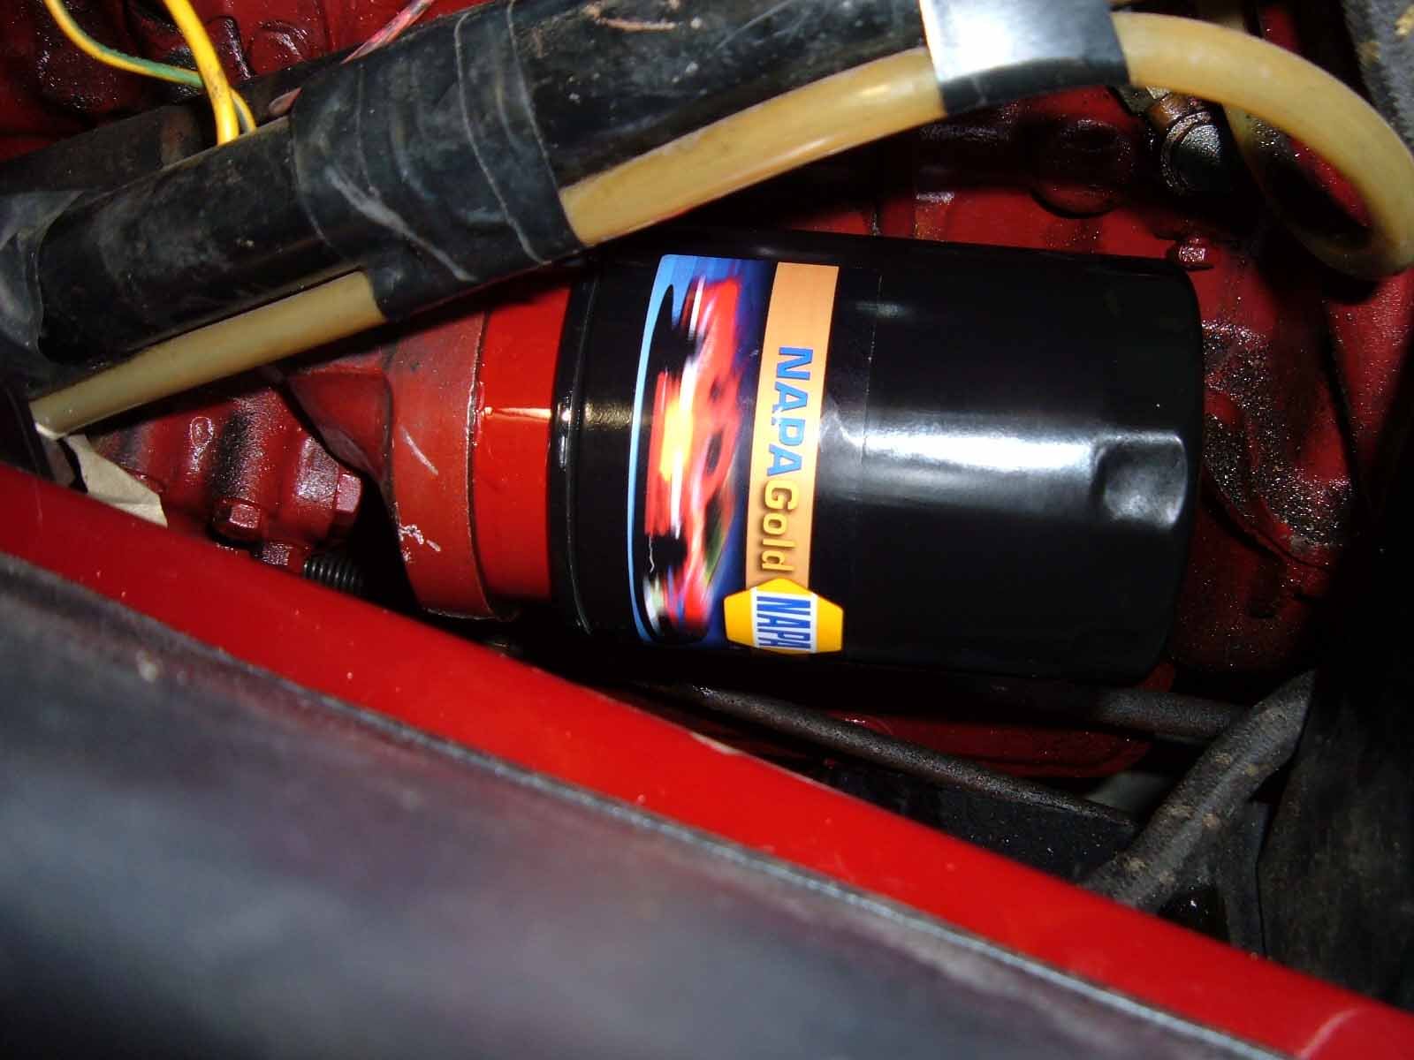

After engine number 14223 (or thereabouts) the oil filter setup underwent a major change for the XPAG engine. The older style with its vertical canister and external plumbing was replaced with a horizontal filter housing and no external plumbing. The filter element was replaceable and up to date for 1952 technology. Quality filter elements are still available from sources such as NAPA (Model 1300) and others. However, they still suffer from a flaw in the original design --- there's no anti-drainback provision.

A few years ago the mechanical wizard, Bob Grunau, came to our rescue. In his magical machine shop, Bob has created an elegantly simple, though robust, adapter that allows one to replace the stock filter with a modern spin-on one. Bob designed his adapter to mate with the very readily available Fram PH-3600 Ford Taurus filter. My personal preference is for its equivalent from Gard, the NAPA 1515, or Wix 21515. If you compare the innards of the 1515 against the 1300 it becomes obvious that the 1515 has much more filtration material and, equally important, it has an anti-drainback provision.

Moss Motors sells the adapter (235-865), but I chose to buy mine directly from Bob for $50US, including shipping (from Canada). Installation is not at all complicated, or time consuming. It's just a matter of unscrewing the old center adapter from the filter housing and replacing it with Bob's adapter. Before installing the new adapter it's a good idea to be certain that you have the proper rubber gasket inside of the filter housing. The correct one has a thickness of about .088". Using a 1" socket, torque the adapter down to about 25 ft. lbs. Smear a bit of oil on the new filter's rubber gasket and spin it on. Follow the filter manufacturer's directions for tightening the filter. Don't overtighten it. You'll probably be doing this in conjunction with an oil change, so don't forget to install the oil. It'll take a bit of cranking to fill the filter so I suggest that you spin the engine over with the ignition off until you get an indication of oil pressure on the gauge before you fire up the engine.

See http://www.ttalk.info/Oil_filter.htm for a detailed look at this operation. Bob Grunau can be contacted at grunau.garage@sympatico.ca, or at 905-274-4136.

